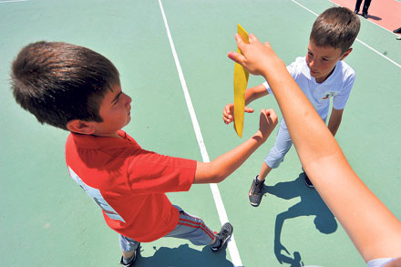
TISSUE PUSS (TURKISH GAME)
- The game is played between two teams with equal numbers of players.
- INSTRUCTIONS:
- Each team should stand on a line facing each other There must be 20-25 meters distance between the lines.
- A circle should be drawn in the middle of two lines. A referee directing the game must be placed in this circle to hold the tissue.
- The referee gives number to each player. There must be two same numbers in different two teams. For example, there must be number “one” in team A and other number “one” in team two.
- The game starts with the instruction of the referee who announces the numbers to come and grab the tissue. For example he says number “three” and number threes from each team run towards the referee to grab the tisssue.
- The contestant who grabs the tissue first runs away to reach his first place on the line. The opponent contestant chases him to take the tissue from him. If he can take place on his line without being caught he continues the game. The other contestant who can not catch his opponent is eliminated and he leaves the game. If catches the contestant and takes the tissue from him, he continues the game.
- At the end whichever team has the bigger number of players wins the game.

DODGE BALL (POLISH GAME BY TURKISH STUDENTS)
- It’s a game that every Pole knows, we all played it in the past and it is still very often played by children of all ages. It is a team game. The idea is to knock down all the players with a ball.
- It has to be made clear that there’s no hitting in the head, that they try to hit in the legs or arms so that nobody gets hurt.
- A playground is divided into two equal fields/halves.
- Players are grouped into two teams with the same number of players .
- They play in two teams facing each other like in volleyball, they don’t cross the line separating their fields.
- Each team chooses one player “a mother” , so there are two mothers and they go behind the opposite team.

- They start to play: first they decide which mother is going to start the game, they draw lots (for example, a coin toss). Then the mother throws the ball trying to hit the enemy (a player from the opposite team ). The enemies do their best to escape from the ball not to get hit. The players from the opposite team can catch the ball and the can also throw the ball and hit the enemy. The person who gets hit, leaves the field. The hit does not count if a player grabs the ball, or a player was hit but someone from his team catches the ball before it touches the ground.
- Players mustn’t escape from the ball by leaving their field! If the ball falls out of the field, the ball takes the mother who is closer to the ball.
- The players who were hit may go the their mother and help her catch the ball and hit the players. Also you can also play for points, you can decide before the game how many players you have to hit to win the game or you play until the last player is hit and sunk

